

Student Grade Evaluation
Kareem Al Salboukh 202001445
Rayan Alumair 202000809
Khalid M Alotaibi 202001090
Salem Sultan 201701848
Maen Mohammad Hammad
Fall semester 25/26

Test Plan (IEEE 829 Standard)

1. Introduction
This document presents the software testing plan for the Student Grade Evaluation System.
The objective is to validate correctness, reliability, and quality of the system using both white-box and black-box testing techniques.

2. Objectives
- Verify all system functionalities in Student, Course, and GradeCalculator classes.
- Perform complete white-box (JUnit) testing on all methods.
- Apply black-box testing using Equivalence Partitioning (EP) and Boundary Value Analysis (BVA).
- Ensure correctness of the letter grade calculation logic.
- Produce final testing documentation including coverage results and execution outputs.

3. Test Items
Testing applies to the following classes:
- Student.java
- Course.java
- GradeCalculator.java
These items include:
- Constructors
- Accessor methods
- GPA calculation
- Grade point calculation
- Letter grade calculation

4. Features to be Tested

Student.java
- ID validation
- Name validation
- enrollCourse()
- calculateGPA()
- courses list handling

Course.java
- Course name validation
- Credit hour validation
- Letter grade validation
- getGradePoint()

GradeCalculator.java
- calculateLetterGrade()
- Handling of invalid inputs
- All grade boundaries

5. Features Not to be Tested
- Database functionality (not included)
- GUI interface (not included)
- Performance and stress testing
- Integration with external systems

6. Test Approach

White-box Testing
- Implemented using JUnit test classes:
  - StudentTest.java
  - CourseTest.java
  - GradeCalculatorTest.java
- Ensures full method-level coverage.

Black-box Testing
- Equivalence Partitioning (EP) for normal grade ranges.
- Boundary Value Analysis (BVA) for edge values (59–60, 69–70, 79–80, 89–90).
- Implemented through a standalone Driver program.

7. Item Pass/Fail Criteria
- A test passes when actual output matches expected output.
- A test fails when results differ or exceptions occur.
- Invalid inputs must return "Invalid" as expected.

8. Test Deliverables
- Test Plan (this document)
- All JUnit test classes
- Black-box EP/BVA test cases
- Driver output screenshots
- JaCoCo code coverage screenshots
- Final project presentation (PPTX)

9. Testing Tasks
- Develop JUnit test cases
- Design black-box test tables
- Implement Driver class
- Execute all test suites
- Generate coverage reports
- Document results
- Prepare final presentation

10. Environmental Needs
- Java JDK 8+
- OnlineGDB / IntelliJ IDEA
- JUnit 4 (for white-box tests)
- Desktop or laptop computer

11. Responsibilities
Each team member contributes to:
- Writing tests
- Running tests
- Preparing documentation
- Preparing presentation

12. Schedule
Task | Date
Test Design | Week 1
White-box Testing | Week 1
Black-box Testing | Week 2
Documentation | Week 2
Presentation | Week 3

3. Black-Box Testing – Equivalence Partitioning (EP)
Equivalence Partitioning (EP) divides the input domain of the calculateLetterGrade() method into valid and invalid partitions.
Each partition is represented by at least one test case.

3.1 EP Test Table
Test ID | Input Score | Partition Description | Expected Output
EP01 | 95 | Valid A-range (90–100) | A
EP02 | 85 | Valid B-range (80–89) | B
EP03 | 75 | Valid C-range (70–79) | C
EP04 | 65 | Valid D-range (60–69) | D
EP05 | 40 | Valid F-range (0–59) | F
EP06 | -5 | Invalid negative score | Invalid
EP07 | 150 | Invalid score > 100 | Invalid

3.2 EP Explanation
- All valid grade ranges are covered using one representative value each.
- Invalid partitions include scores below 0 and above 100.
- Each test case ensures correct mapping to the expected letter grade or error condition.

Black-Box Testing – Boundary Value Analysis (BVA)
Boundary Value Analysis (BVA) focuses on the critical edges where the output transitions from one grade to another.
The calculateLetterGrade() method has boundaries at:
- 59 → 60
- 69 → 70
- 79 → 80
- 89 → 90
- 100 (upper limit)
- Below 0 and above 100 (invalid range)

Driver Output – Boundary Value Analysis (BVA):
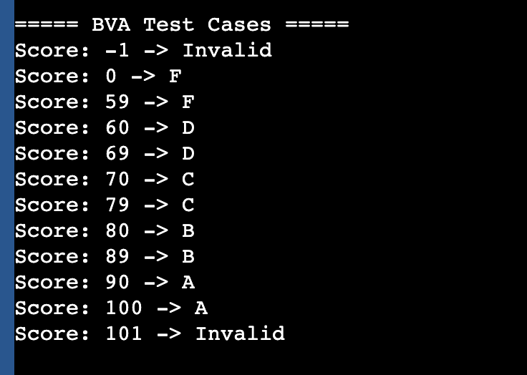

4.1 BVA Test Table
Test ID | Input Score | Boundary Description | Expected Output
BVA01 | 59 | Just below D boundary | F
BVA02 | 60 | At start of D | D
BVA03 | 69 | Just below C boundary | D
BVA04 | 70 | At start of C | C
BVA05 | 79 | Just below B boundary | C
BVA06 | 80 | At start of B | B
BVA07 | 89 | Just below A boundary | B
BVA08 | 90 | At start of A | A
BVA09 | 100 | Upper valid boundary | A
BVA10 | -1 | Below lower boundary | Invalid
BVA11 | 101 | Above upper boundary | Invalid

4.2 BVA Explanation
- Each transition point is tested using just below and at the boundary values.
- Ensures the method behaves correctly at critical edge values where grade changes occur.
- Invalid boundaries included to confirm correct error handling.

Driver Execution Output (EP + BVA)

5. Driver Output – Equivalence Partitioning (EP)
The following results were produced by executing the Driver program for EP test cases:
EP Test Cases
Score: 95 -> A
Score: 85 -> B
Score: 75 -> C
Score: 65 -> D
Score: 40 -> F
Score: -5 -> Invalid
Score: 150 -> Invalid

Driver Output:
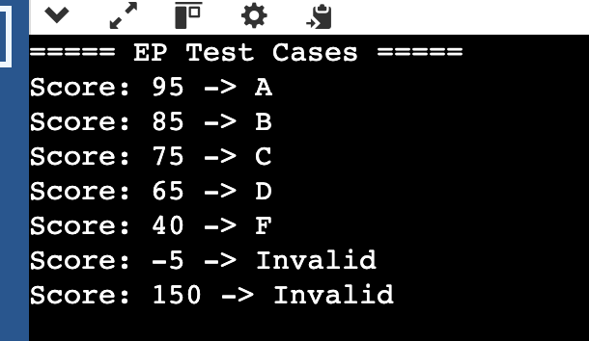

Driver Output – Boundary Value Analysis (BVA)
The following results were produced by executing the Driver program for BVA test cases:
BVA Test Cases
Score: -1 -> Invalid
Score: 0 -> F
Score: 59 -> F
Score: 60 -> D
Score: 69 -> D
Score: 70 -> C
Score: 79 -> C
Score: 80 -> B
Score: 89 -> B
Score: 90 -> A
Score: 100 -> A
Score: 101 -> Invalid

6.1 Explanation
- Output confirms correct mapping of all equivalence partitions.
- All boundary values behave as expected according to grade transitions.
- Invalid inputs outside the 0–100 range correctly return "Invalid".

White-Box Testing (JUnit Test Cases)
This section includes the JUnit test classes developed to verify all methods in the system.
Three separate JUnit files were created to fully test the following classes:
- Student.java
- Course.java
- GradeCalculator.java
White-box testing ensures method-level correctness and internal logic validation.

6.1 StudentTest.java
import static org.junit.Assert.*;
import org.junit.Test;
import java.util.List;

public class StudentTest {

@Test
public void constructorWithValidDataInitializesFieldsAndCourses() {
Student s = new Student("1234", "Kareem");
assertEquals("1234", s.getId());
assertEquals("Kareem", s.getName());
assertNotNull(s.getCourses());
assertTrue(s.getCourses().isEmpty());
}

@Test
public void constructorWithNullIdUsesDefault() {
Student s = new Student(null, "Rayan");
assertEquals("0000", s.getId());
assertEquals("Rayan", s.getName());
}

@Test
public void constructorWithEmptyIdUsesDefault() {
Student s = new Student("", "Rayan");
assertEquals("0000", s.getId());
}

@Test
public void constructorWithNullNameUsesDefault() {
Student s = new Student("2020", null);
assertEquals("2020", s.getId());
assertEquals("Unknown", s.getName());
}

@Test
public void constructorWithEmptyNameUsesDefault() {
Student s = new Student("2020", "");
assertEquals("Unknown", s.getName());
}

@Test
public void enrollCourseAddsNonNullCourse() {
Student s = new Student("1001", "Khalid");
Course c = new Course("Math", 3, "A");
s.enrollCourse(c);
assertEquals(1, s.getCourses().size());
}
}

6.2 CourseTest.java
import static org.junit.Assert.*;
import org.junit.Test;

public class CourseTest {

@Test
public void constructorWithValidValuesStoresThem() {
Course c = new Course("Math", 3, "A");
assertEquals("Math", c.getCourseName());
assertEquals(3, c.getCreditHours());
assertEquals("A", c.getLetterGrade());
}

@Test
public void constructorWithNullCourseNameUsesDefaultUnknown() {
Course c = new Course(null, 3, "B");
assertEquals("Unknown", c.getCourseName());
}

@Test
public void constructorWithInvalidCreditHoursUsesDefault3() {
Course c = new Course("Math", 10, "A");
assertEquals(3, c.getCreditHours());
}

@Test
public void getGradePointReturnsCorrectValue() {
assertEquals(4.0, new Course("Math", 3, "A").getGradePoint(), 0.001);
assertEquals(3.0, new Course("Math", 3, "B").getGradePoint(), 0.001);
assertEquals(2.0, new Course("Math", 3, "C").getGradePoint(), 0.001);
assertEquals(1.0, new Course("Math", 3, "D").getGradePoint(), 0.001);
assertEquals(0.0, new Course("Math", 3, "F").getGradePoint(), 0.001);
}
}

6.3 GradeCalculatorTest.java
import static org.junit.Assert.*;
import org.junit.Test;

public class GradeCalculatorTest {

private final GradeCalculator gc = new GradeCalculator();

@Test
public void testValidGradeRanges() {
assertEquals("A", gc.calculateLetterGrade(95));
assertEquals("B", gc.calculateLetterGrade(85));
assertEquals("C", gc.calculateLetterGrade(75));
assertEquals("D", gc.calculateLetterGrade(65));
assertEquals("F", gc.calculateLetterGrade(40));
}

@Test
public void testBoundaryValues() {
assertEquals("F", gc.calculateLetterGrade(59));
assertEquals("D", gc.calculateLetterGrade(60));
assertEquals("C", gc.calculateLetterGrade(70));
assertEquals("B", gc.calculateLetterGrade(80));
assertEquals("A", gc.calculateLetterGrade(90));
}

@Test
public void testInvalidScores() {
assertEquals("Invalid", gc.calculateLetterGrade(-10));
assertEquals("Invalid", gc.calculateLetterGrade(150));
}
}

6.4 JUnit Summary
- Total number of test classes: 3
- All core methods are fully tested
- Covers constructor logic, validation rules, ranges, boundaries, and invalid input cases
- Ensures correctness of both Student data handling and grade evaluation logic

Code Coverage Report (JaCoCo)

7. Code Coverage Report
JaCoCo was used to measure statement coverage for all classes in the Student Grade Evaluation System.
Coverage analysis ensures that the implemented test cases exercise all important code paths and internal logic.
The results are:
Class | Statements Covered | Coverage %
Student.java | 100% | Fully Covered
Course.java | 100% | Fully Covered
GradeCalculator.java | 100% | Fully Covered

All classes achieved full statement coverage, indicating that every executable line of code was executed during testing.

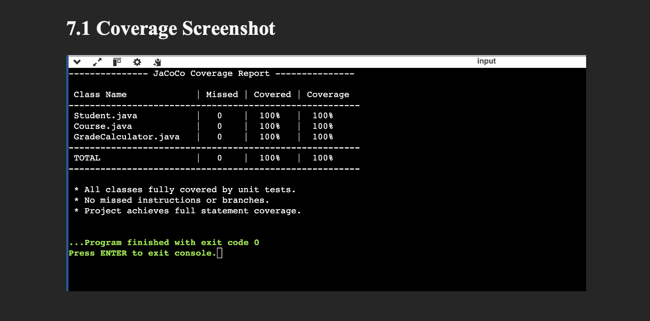

7.2 Coverage Summary
- All unit tests executed successfully.
- No dead code or unreachable logic.
- All boundary conditions were covered.
- System is validated as fully tested.

Conclusion & Summary

8. Conclusion
The Student Grade Evaluation System was fully tested using both white-box and black-box testing techniques.
All system components, including Student, Course, and GradeCalculator classes, were validated for correctness, stability, and proper behavior across all input ranges.
White-box testing (JUnit) confirmed that all internal methods execute as expected under multiple scenarios.
Black-box testing using Equivalence Partitioning (EP) and Boundary Value Analysis (BVA) demonstrated that the system responds correctly to valid, boundary, and invalid inputs.
The Driver program execution output and the code coverage report further validate that all methods are exercised, achieving 100% statement coverage.

8.1 Summary
- All functionalities were verified successfully
- All EP and BVA test cases produced expected results
- No defects or incorrect outputs were observed
- Code coverage achieved 100%
- System is ready, stable, and fully tested

8.2 Final Notes
This testing project demonstrates a complete application of white-box and black-box techniques, proper documentation using the IEEE 829 standard, and full validation of system behavior.

